**Lab 3: Oscilloscope and Function Generator**

Daniel Komac

EEE 117L Section 05

2pm-4:50pm

**Purpose:**

To further our understanding of the new oscilloscopes that we are required to use on the following circuit: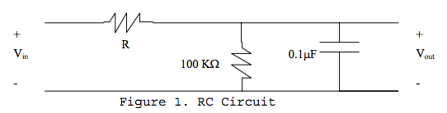

**Procedure:**

Analyzing the phase shift of 45 degrees between Vin and Vout. Our resistance value R was part of our pre lab. The resistance value we abotained was 1.5kOhms but the resistor we were able to find was of 1565.78 Ohms so there is some error in our calculations though we obtained around the same measured values as the oscilloscope.

**Discussion Topics:**

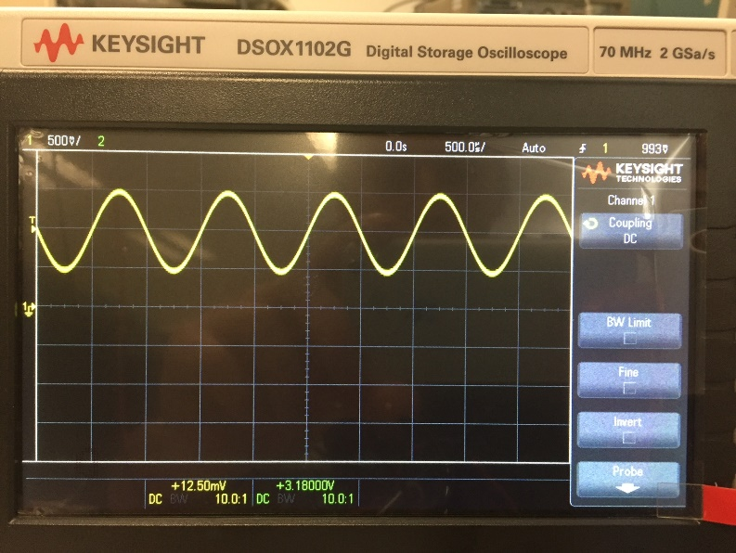1. When we were using a coupling for DC and AC we noticed one small difference and it was the AC was displayed along our 0 X axis while the DC one was displayed some voltage higher than our 0. This being that DC needs a Voltage DC offset of about 1 or 2 volts to correctly display the information on the oscilloscope. The sinusoidal waves are also of minutely different frequencies because the period is accelerated in ac.

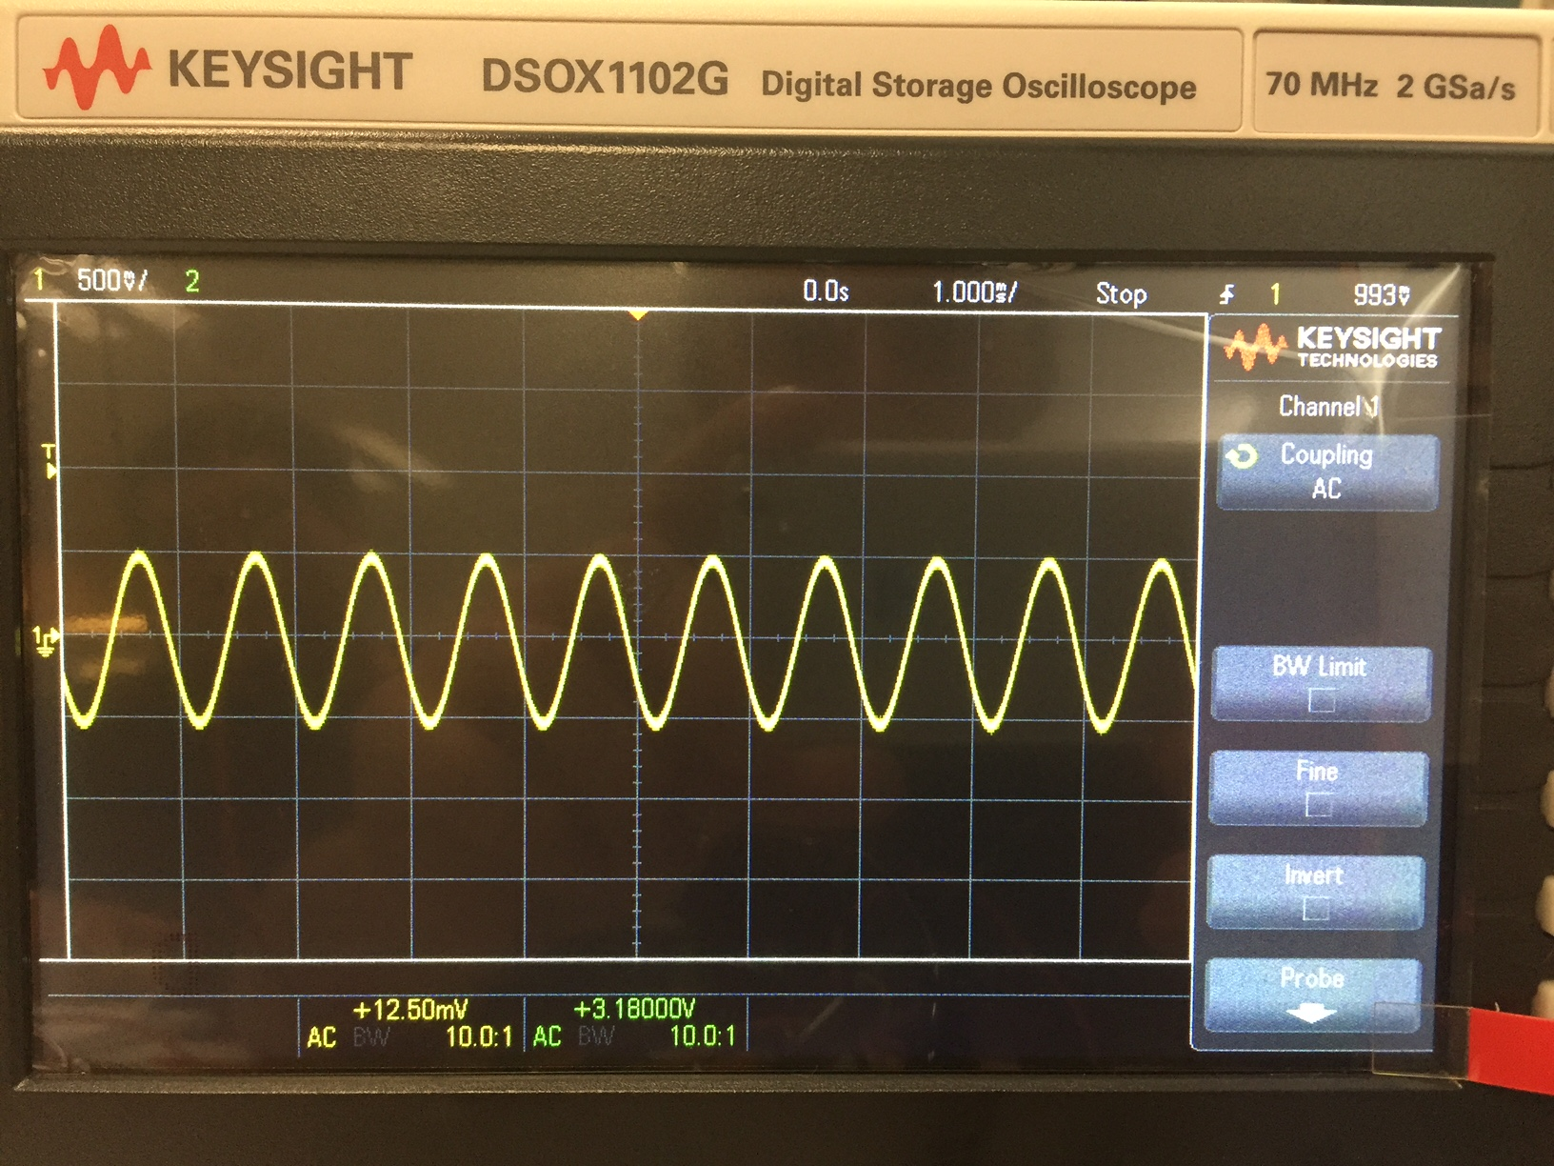

2. This was the resultant image we received when we hooked up the given circuit, this being the two measured frequencies, Vin and Vout of the circuit being at 45 +|- 2 degrees.

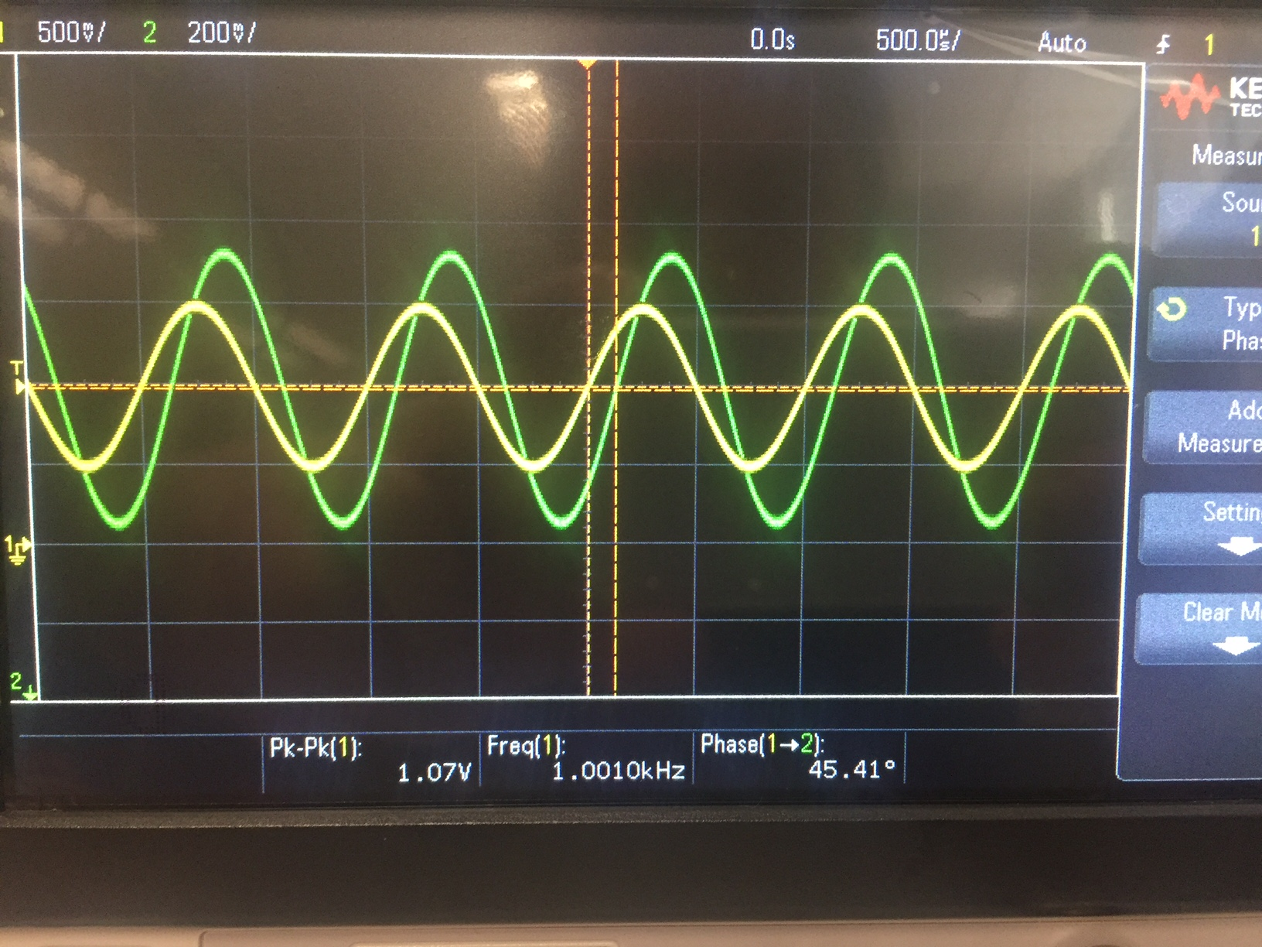

3. The X1 X10 and X100 probes are used in measuring determined values at the probe location. These probes are all of different resistance and used in different analytical situations. The probe we proceeded to use was the X1 probe since it offered the least amount of resistance therefore interfering with the circuit less. The X1 giving us a max voltage of 2.5V while the X10 gives us a max voltage of 5V. We didn’t have an X100 probe or a variable probe with X100 so we could not exactly measure the given values.

4. When the trigger was switched from a + voltage to a – voltage value the wave form began to scroll across the screen.

5. Switching from “AUTO” and “NORM” yielded drastic differences, to the oscilloscope appearance for this lab. “AUTO” cause the oscilloscope to scroll while “NORM” yielded a stable chart.

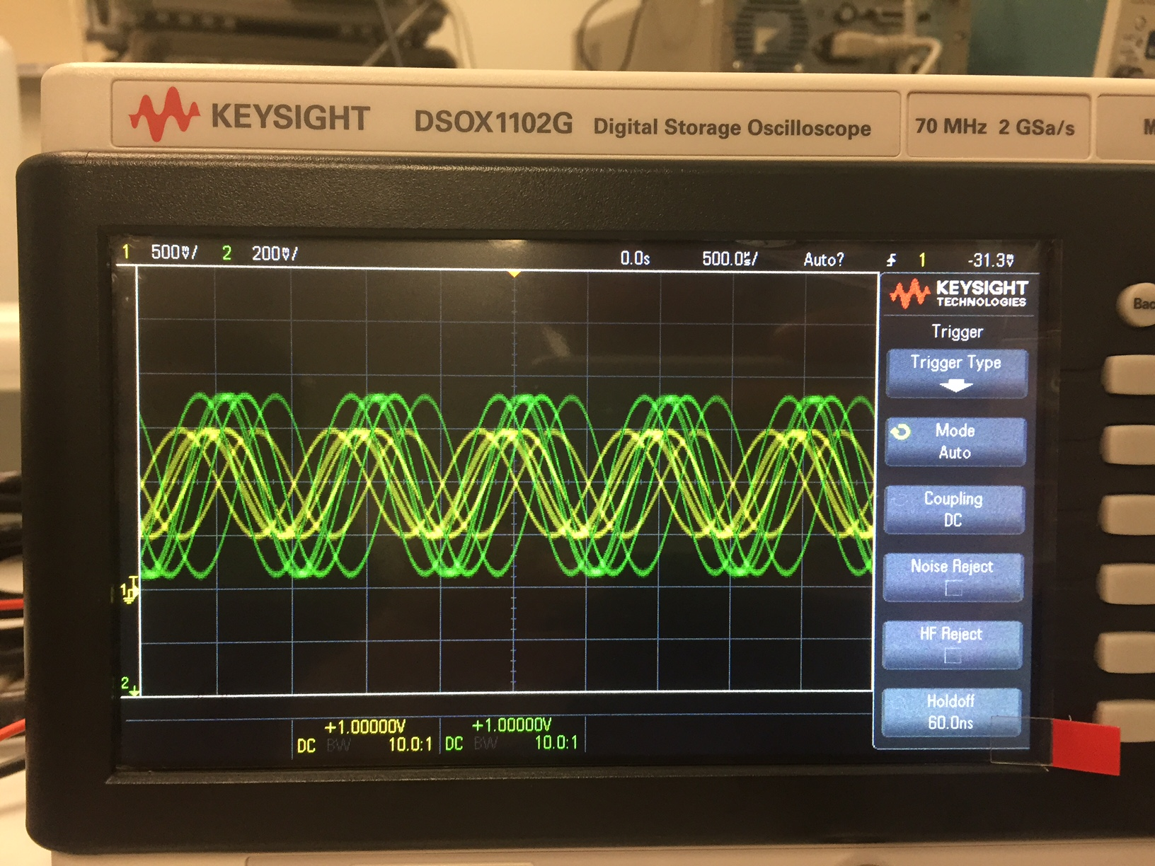

6. The significance of the 51 Ohm resistance of the function generator is to provide a slight offset for your circuit to draw an appropriate current. With this comes some mismatched information on the oscilloscope due to unwanted/unneeded resistance. The resistance usually changes our peakV by 1 V or less. This is because the probe cannot see the voltage before the drop of the 51 ohm resistor.

7. By the end of the lab when the equation, *Phaseshift =* 360 * *(timedelay/period)*, was used to determine if we got appropriate values for our phase shift. The values we measured to calculate these are as follows on the spread sheet and following pictures corresponding to the delay between our two different probes.

